

**TREC IRELAND NATIONAL PTV & MA**

**CHAMPIONSHIPS 2015**

**CLASSES: PTV (obstacles) and MA (control of paces)**

**X-TREC (x-country and PTV) and VERSATILE TREC (dressage and PTV)**

**AT PUNCHESTOWN, CO KILDARE ON 11TH OCTOBER 2015**

**SCHEDULE**

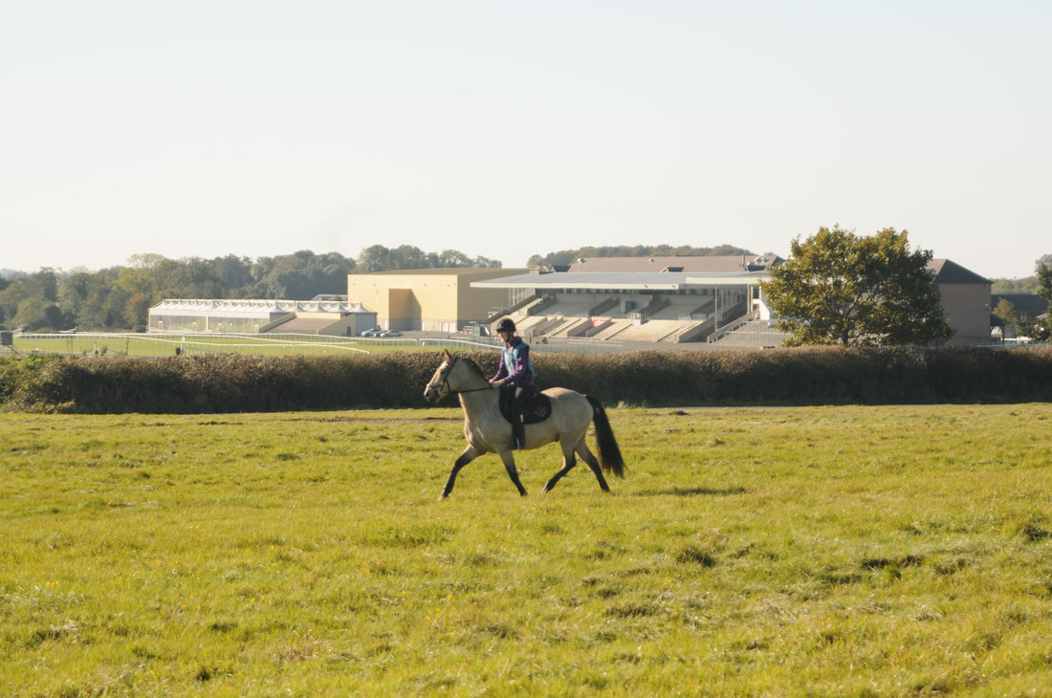

**TREC Ireland would like to thank all our generous sponsors:**

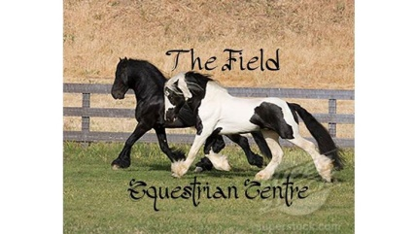

**The Field Equestrian Centre**, Ballyadams, Co. Laois

<https://www.facebook.com/TheField-EquestrianCentre-938289066195835/timeline/>

* sponsoring PTV Non-Championship classes

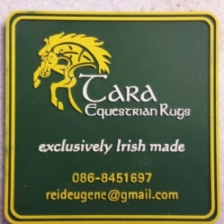

**Tara Equestrian**, Kilcullen, Co. Kildare

<https://www.facebook.com/tara.equestrian?fref=ts>

* sponsoring Versatile TREC



**Institute of Natural Medicines Ireland**, Castleknock, Dublin 15

<http://www.inmi.ie/>

* sponsoring X-TREC

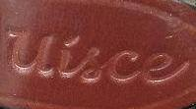**Uisce Saddlery**, Dingle, Co. Kerry

<http://www.uiscesaddlery.com/>

* sponsoring PTV Championship Team Competition

*The winners of the Championships classes will be presented with perpetual trophies:*

* Open PTV – ***Coolroe Gold Perpetual Trophy*** sponsored by **Leinster TREC**
* Intermediate PTV – ***The Fastnet Perpetual Trophy*** sponsored by **West Cork TREC**
* Novice PTV – ***The Tara Perpetual Shield*** sponsored by **Kerry TREC**
* MA Championships – ***McSwiggan Perpetual Trophy*** sponsored by **Turas TREC**

Prizes for Championship classes kindly sponsored by:

The Field Equestrian Centre, Ballinagappa House Stables and Saoirse Saddlery

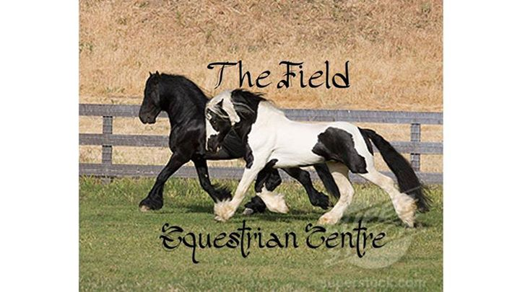 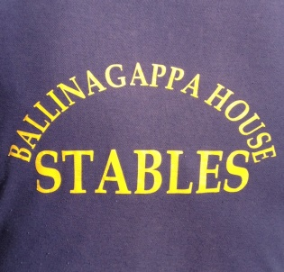 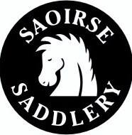

TECHNICAL DELEGATE: Adrian Flynn ORGANISERS: Niamh Ó hUid/Ailbhe Gavin

**CONTACT INFORMATION**

Diana O hUid [dianaohuid@gmail.com](mailto:dianaohuid@gmail.com)

Website: www.trecireland.ie

Facebook: TREC Ireland and Leinster TREC pages

**COMPETITION INFORMATION**

The PTV and MA Championship classes are open to riders who have qualified or been nominated to represent their TREC group. The highest scoring competitor in each Championship class will be awarded perpetual trophies sponsored by four TREC groups.

The PTV classes are open to all riders **not** competing in a Championship class. They will be over the same course as the Championship class. The MA is only open to qualified/nominated competitors.

The PTV and X-TREC courses will be set across Punchestown’s impressive x-country course, in view of the iconic Racetrack and Grandstand.

X-TREC and Versatile TREC are open to all riders. Rules and Versatile TREC tests can be found attached at the end of the schedule.

Junior Versatile TREC is an option for all under 16s who do not wish to ride on the PTV course. Under 16s can also take part in the other classes if they are confident riding in open fields.

There will be an unsponsored lead rein class using the same test as Junior Versatile TREC.

Small rosettes for everybody.

**ENTRIES**

Entries MUST be pre-paid and sent in on the attached Entry Form. Closing date for entries is **Friday 2nd October 2015.** Entries should be sent (by post or email) to Diana O hUid, 5 Abbey Park View, Clane, Co Kildare [dianaohuid@gmail.com](mailto:dianaohuid@gmail.com). Cheques should be made payable to TREC Ireland.

Our bank details are as follows:

**Please include rider name if doing bank transfer**.

Account Name: Tourism Related Equestrian Competitions Ireland Ltd

Bank: AIB, 1-3 Castle Street, Tralee, Co Kerry

IBAN: IE41 AIBK 9362 1969 9620 84

BIC: AIBKIE2

**CLASSES**

Class 1: MA Championships

Class 2: Open PTV Championships (Level 3 measurements)

Class 3: Open PTV Class (Level 3 measurements)

Class 4: Intermediate PTV Championships (Level 2 measurements)

Class 5: Intermediate PTV Class (Level 2 measurements)

Class 6: Novice PTV Championship (Level 1 measurements)

Class 7: Novice PTV Class (Level 1 measurements)

Class 8: Open X-TREC (Max height 95cm)

Class 9: Novice X-TREC (Max height 80cm)

Class 10: Open Versatile TREC

Class 11: Novice Versatile TREC

Class 12: Junior Versatile TREC

Class 13: Lead Rein TREC

**ENTRY FEES**

**TREC Ireland Member Non-Member**

One class €15 €20

Two classes €25 €35

Three classes €35 €45

MA Championship €10 €10

Lead-rein class €10 €10

**IMPORTANT RULES TO NOTE**

At this event we will be strictly adhering to the following TREC Ireland rules:

* 3.6.1. Competitors may be eliminated for receiving outside assistance during the MA or PTV. Catching a loose horse is allowed.
* 6.7.5. A rider not wanting to attempt an obstacle must:
  + Stop
  + Approach the obstacle judge
  + Inform the judge of his intention not to attempt the obstacle

Failure to do this will result in elimination from the phase.

**BODY PROTECTORS**

Riders 18 years and under must wear a body protector for the PTV phase of the competition. TREC Ireland recommends that all riders wear body protectors.

**ACCOMMODATION**

This is a 1-day event but, should you wish to travel the previous day, and make it more of a holiday!, there are B&Bs available from €35 per night sharing. You can be accommodated close to wherever your horse is. List of accommodation attached. Please contact Laura Murtagh: Email: [murtaghlaura@gmail.com](mailto:murtaghlaura@gmail.com) or Mobile: 086 3735579 (text only) if you have any questions.

**STABLING/CORRALLING/CAMPING**

Stabling, corralling and camping are available at Kildare International Equestrian Centre, Winterdown Stud, Rathmore, Co Kildare. €20 for stable (including shavings and haylage) €10 for corral (includes camping). Spots to be booked through event organisers. Please send fee with entry and specify number of stables, corrals or camping spots required.

**EQUIPMENT**

The following items of equipment are **mandatory** for all riders:

* Medical Armband
* If riding with a martingale your horse must wear a headcollar and rope for In-Hand obstacles.
* Body protectors for under 18s.

**CATERING**

We are delighted to tell you that Geraldine Creighton will be running her Punchestown Café during our event. She has a wide range of sandwiches, home-made soup and a great selection of delicious cakes, freshly made (can highly recommend these!!) Hot and cold drinks also available. **Lunch tokens will be provided to all helpers**. The menu is attached to tempt you, so start choosing!!

**VOLUNTEERS**

All TREC competitions rely on the support of volunteer judges and helpers. Can you, or anyone coming with you, lend a hand? Please enclose, with your entry, details of anyone who would be available to help with stewarding or judging during the event. No qualifications necessary. We are grateful for all offers of help. There are also jobs suitable for non-horsey people. Free delicious lunch provided!!

**PASSPORTS**

It is a legal requirement to carry a passport when a horse is used for the purposes of competition. If a horse is transported without a passport when being used for competition purposes, an offence is being committed and prosecution is a possibility.

**CODE OF ETHICS**

TREC Ireland’s ‘Code of Ethics & Good Practice for Children’s Sport’ will be adhered to for this event.

- All parents must fill in ‘Junior Participants Form’ (page 29 of the Code)

- All parents and junior participants must fill in the entry form with the understanding that they ‘agree to abide by TREC Ireland’s code of ethics and good practice’ – this also allows TREC Ireland to include photos of the junior participants on the internet and any newspapers such as The Irish Field.

- Anybody involved in any way with the event on any or all days, must sign in using the provided sign in sheet (in the Entries office)

- Any junior helper must either be accompanied by two adults, an adult family member, or must fill out p18 of the code, ‘Travelling Leader’ form. It is up to the junior helper to get this filled out and NOT the duty of the organiser.

The code is available to download on [www.trecireland.com](http://www.trecireland.com)

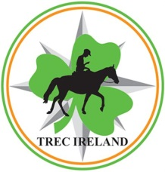**TREC Ireland National PTV & MA**

**Championships 2015**

**Entry Form**

**RIDER:**

Name: Email:

Address: Phone:

TREC Ireland Membership Number & Expiry date:

Age (if under 18): *Please fill out and return attached U18 form*

**HORSE:**

Name: Height:

Equine Premises Number: Breed:

(Please indicate if riding a stallion)

**CLASS:**

Class 1: MA Championships - €10

One Class 2-12 - €15/€25 Please specify which class you would like to enter ______

Two Classes (2-12) - €25/€35 Please specify which two classes you wish to enter ______

Three Classes (2-12) - €35/€45 Please specify which three classes you wish to enter _____

Class 13: Lead rein - €10

**Volunteer:**

Name:

Email: Phone:

**Payment:**

Post entry form to: Diana O hUid, 5 Abbey Park View, Clane, Co Kildare

Email: [dianaohuid@gmail.com](mailto:dianaohuid@gmail.com)

Entries close**: Friday 2nd October 2015**

Cheque Bank Transfer

*Please include rider name if doing bank transfer. Our Bank Account details are:*

*Account Name: Tourism Related Equestrian Competitions Ireland Ltd*

*Bank: AIB, 1-3 Castle Street,Tralee, Co Kerry*

*IBAN:* IE41 AIBK 9362 1969 9620 84 *BIC: AIBKIE2D*

***For Under 18s:***

I hereby agree to abide by TREC Ireland’s code of ethics and good practice:

Signed: ……………………………………………………………… Date: …………………………………………

Parent/ Guardian

Signed: ……………………………………………………………… Date: …………………………………………

Junior Participant



**TREC Ireland National PTV & MA Championships 2015**

**Next of Kin Form**

**(Please return this with your entry form)**

**Name of Competitor:………………………………**

**Level:………..**

**Name of Horse:………………………………**

**Transport Registration:……………………...**

**Next of Kin:………………………………………**

**Address:………………………………………….**

**Telephone:……………………..**



**Emergency Contact Stabling Form**

**NAME:……………………………………………………………………**

**MOBILE NO: ……………………………………………………………**

**HORSE NAME: ……………………………………..**

 **Junior Participants** 

**To be completed for all participants under 18 years of age.**

**Contact Information**

Name:

Address:

Telephone – Home:

Mobile ( in case of emergency) :

Email:

Date of Birth:

Medical History Information (details of any known allergies, conditions, medications)

In the event of illness, having parental responsibility, I give permission for medical treatment to be administered where considered necessary by a nominated first aider, or by suitably qualified medical practitioners. If I cannot be contacted and my child needs emergency hospital treatment, I authorise a qualified medical practitioner to provide emergency treatment or medication.

Any other special needs, requirements or directions that would be helpful for leaders to know about:

**Parental/Guardian Consent**

I am the parent/guardian of

I understand that photographs will be taken during events and may be used in the promotion of sport.

I hereby consent to the above child participating in activities of the organisation in line with the Code of Ethics for Young People. I adhere to TREC Ireland’s parents’ code of conduct.

I confirm that all details are correct and I am able to give parental consent for my child(ren) to participate in all activities.

Signature: Print Name: Date:

**Participant:**

I adhere to TREC Ireland’s rules and Code of Ethics for Young Participants

Signed: Print name: Date:

Details of TREC Ireland’s Code of Ethics can be found on [www.trecireland.com](http://www.trecireland.com)

***Café Menu***

**Country Vegetable Soup served with Farmhouse Brown Bread €3.00**

**Sandwich Selection**

**Available on sliced white or brown bread, rolls, farm house brown bread or wraps**

**The Hippy Chick :**

**Free Range Egg Salad with Chives and Mayonnaise €2.50**

**The Smiler :**

**Dubliner Cheddar Cheese with Ballymaloe Country Relish €2.50**

**The Oinker :**

**Home baked, Honey Glazed Ham with Ballymaloe Country Relish €3.00**

**The Ploughhorse :**

**Home baked, Honey Glazed Ham, Dubliner Cheddar Cheese, €3.50**

**Salad leaves,Tomato slices, Red Onion and Pickle.**

**The Water Baby:**

**Tuna Fish with Sweetcorn, Chives and Mayonnaise €3.00**

**Toasty Special:**

**Honey Baked Ham, Dubliner Cheese, Tomato slices and onion €3.00**

**Little Treats**

**.**

**Toast with Homemade Jam €1.50**

**Plain or Fruit Scone with Homemade Jam €1.50**

**Bramley Apple and Cinnamon Tart with Fresh Cream €2.50**

**Bakewell Tart €2.50**

**Cupcakes Vanilla /Lemon/ Chocoalate €1.50**

**Coffee Slice €1.50**

**Chocolate Bars €1.00**

**Our cakes are all homemade using the freshest ingredients and no artificial preservatives**

**Beverages**

**Tea €1.50**

**Coffee €1.50**

**Drinking Chocolate: €2.50**

**With Marshmallows and Fresh Cream**

**Minerals Cans of Coke, 7up, Club Orange €1.00**

**Water €1.00**

**Juice Ribena Apple or Blackcurrant €0.80**

**Accommodation**

[Dolores Brophy](mailto:leonieb1@eircom.net?subject=Accomodation)**,**

Newtown,

Punchestown,

045 876332

[Josephine Hardiman](mailto:josephinehardiman@eircom.net?subject=Accomodation),

Punchestown

045 866708 or 086 2452765

Ms Mairead Costello,

Laragh,

Eadestown,

045 862258 or 087 7958536

*A more luxurious option!!*

Moate House,

Rathmore,

045 862154

<http://www.moatehouse.ie/>

**Naas – Approx 3 miles from Punchestown**

Malones B&B

1 The Sycamores

Sallins Road

Naas

Phone: 045 897598

Email: [miriammalone@hotmail.com](mailto:miriammalone@hotmail.com)

Norcenni

Boreen Lusk

Sallins Road

Naas

Phone 045 875 5014

Email: [norcenni@hotmail.com](mailto:norcenni@hotmail.com)

Setanta Farmhouse

Mrs. Joan McLoughlin

Donore,

Caragh,

Naas

Phone: 045 876481

Email: [Naassetantatfarmhouse@eircom.net](mailto:Naassetantatfarmhouse@eircom.net)

**Versatile TREC - Open Test**

1. A Enter at working trot

X Halt, Salute, Mounted Immobility 5 secs, proceed down centre line in working trot

C Track left

2. Between

H & K One loop 5m in from track

After A Down ¾ line – Slalom in working trot

3. Between

C & H Working canter

E K A F Working canter

B Circle left 20m diameter

4. B M C Working canter

After C Down ¼ line through Corridor in working canter

Before A Working trot

5. F X H Change rein

Before X Transition to walk (2-5 steps) & proceed in working trot

6. H C M Working trot

Between

M & F One loop 5m in from track

7. Between

A & K Working canter

E Circle right 20m diameter

E H C Working canter

After C Down ¾ line – Slalom in working canter

8. Between

A & K Working trot

K X M Change rein

Before X Transition to walk (2-5 steps) & proceed in working trot

9. Between

M & C Medium walk

C Reinback 3-4 steps then proceed in medium walk

10. H B Change rein at free walk on a long rein

B F Medium walk

F Working trot

11. A Turn down centre line

X Halt, Mounted Immobility 5 secs, Salute

Leave arena at a free walk on a long rein

**Versatile TREC - Novice Test**

1. A Enter at medium walk

X Halt, Salute, Mounted Immobility 5 secs

Between

X & G Show a progressive transition to working trot

C Track left

2. H E K Working trot

After A Down ¾ line – Slalom in working trot

3. Between

C & H Working canter

E K A F Working canter

B Circle left 20m diameter

4. Between

B & M Working trot

After C Down ¼ line through Corridor in working trot

5. A F Working trot

B Turn left

E Turn right

6. H C Working trot

After C Down ¾ line – Slalom in working trot

7. Between

A & K Working canter

E H C M Working canter

B Circle right 20m diameter

8. Between

F & A Working trot

Between

A & K Medium walk

E Turn right

B Turn left

9. B M Medium walk

C Reinback 3-4 steps then proceed in medium walk

10. H B Change rein at free walk on a long rein

B F Medium walk

Between

F & A Working trot

11. A Turn down centre line

X Halt, Mounted Immobility 5 secs, Salute

Leave arena at a free walk on a long rein

**Versatile TREC - Junior Test**

1. A Enter at medium walk

X Halt, Salute, Mounted Immobility 5 secs

Between

X & G Show a progressive transition to working trot

C Track left

2. H E K Working trot

A Circle left 20m diameter

F X H Change rein in working trot through Slalom

3. C Circle right 20m diameter

K X M Change rein in working trot through Low Branches and Corridor

4. Between

A & F Working canter

F B M C Working canter

C Circle left 20m diameter

5. After C Proceed over Tree Trunk

Between

E & K Working trot

Between

A & F Medium walk

6. B Turn left, S- Bend

E Footbridge, turn right

7. Between

E & H Working trot

Between

C & M Working canter

M B F A Working canter

8. A Circle right 20m diameter

A K E Working canter

Between

E & H Working trot

Between

C & M Medium walk

9. After M Dismount

B Turn right, In-Hand S-Bend

E In-Hand Footbridge, turn left

10. K In-Hand Corridor

X Halt, Salute

Leave arena In-Hand

***VERSATILE TREC RULES***

1. Versatile TREC will be judged in a similar way to a Prix Caprilli test. The obstacles will not be marked using the same rules as for PTV, rather they will be marked as part of a movement. Judge will be looking for balance, rhythm, obedience, and effectiveness of rider aids.

2. Penalties for obstacles:

* 1st Refusal – 3 penalties
* 2nd Refusal – 6 penalties
* 3rd Refusal – 0 points for that movement
* Fall of horse or rider – Elimination

3. Riders may have test called out but outside interference will result in elimination from the class.

4. Obstacles in Novice test will be set to Level 1 measurements. Obstacles in Open test will be set to Level 2 measurements.

5. Boots and bandages are allowed.

6. A jumping or dressage stick is allowed. Competitors in the open class may wear spurs **or** carry a stick. (Spur rules to Dressage Ireland rules. Please see the following link; <http://www.dressageireland.ie/members/rulebook/>)

7. Martingales are not permitted. There are no other rules regarding tack allowed.

8. Any incorrect equipment will incur a penalty of minus 10.

9. There is no dress code for Versatile TREC but horse and rider must be presented clean and neat.

10. Test to be ridden in a 20x40m sand arena.

***JUNIOR VERSATILE TREC RULES***

1. Versatile TREC will be judged in a similar way to a Prix Caprilli test. The obstacles will not be marked using the same rules as for PTV, rather they will be marked as part of a movement. Judge will be looking for balance, rhythm, obedience, and effectiveness of rider aids.

2. Penalties for obstacles:

* 1st Refusal – 3 penalties
* 2nd Refusal – 6 penalties
* 3rd Refusal – 0 points for that movement
* Fall of horse or rider – Elimination

3. Riders may have test called out but outside interference will result in elimination from the class.

4. Obstacles in will be set to Level 1 measurements.

5. Boots and bandages are allowed.

6. Martingales are not permitted. There are no other rules regarding tack allowed.

7. A jumping stick is permitted but dressage whips and spurs are not allowed.

8. Any incorrect equipment will incur a penalty of minus 10.

9. Body protectors **must** be worn by **all** competitors. (There will be a couple of small body protectors available to borrow if needed)

10. There is no dress code for Versatile TREC but horse and rider must be presented clean and neat.

11. Test to be ridden in a 20x40m sand arena.

***X-TREC RULES***

1. X-TREC course will include 8 x-country fences and 8 PTV obstacles.

2. Maximum height for Opens class is 95cm. Maximum height for Novice class is 80cm.

3. X-country fences will be judged as style obstacles in the same manner as Tree Trunk, Hedge or Path Crossing. (see TREC Ireland Data sheets; <http://trecireland.webs.com/apps/documents/>)

4. There will be no In-Hand obstacles.

5. Outside interference will result in elimination from the competition. Catching a loose horse is allowed.

6. All obstacles are optional, however if you do not wish to complete an obstacle you must STOP at the judge and inform them that you do not wish to complete the obstacle. Failure to show a definite break in forward motion will result in elimination from the class.

7. Falls – as per TREC Ireland PTV rule 6.10;

*“A fall during this phase does not result in elimination unless the judge nearest to the rider at the time of the fall, with approval of the Technical Delegate/Ground Jury, considers the competitor unfit to continue. The judge can stop the competitor temporarily, neutralising her/his time, until the Technical Delegate decides whether the competitor can continue or not. If the fall is a consequence of the obstacle, it is marked with 10 penalties by the judge of this obstacle. If the fall is between obstacles, it is marked with 10 penalties by the judge of the following obstacle. The judges must notify the Technical Delegate of all rider and horse falls as soon as possible and must note it clearly on the scoring sheet. After a second rider fall (not including falls when leading) the rider must not remount but must leave the course leading her/his horse. Remounting after two falls will result in elimination from the event and the rider being asked to appear before the disciplinary panel. “*

8. Body protectors must be worn by all under 18 riders. TREC Ireland recommends that all competitors wear a body protector.